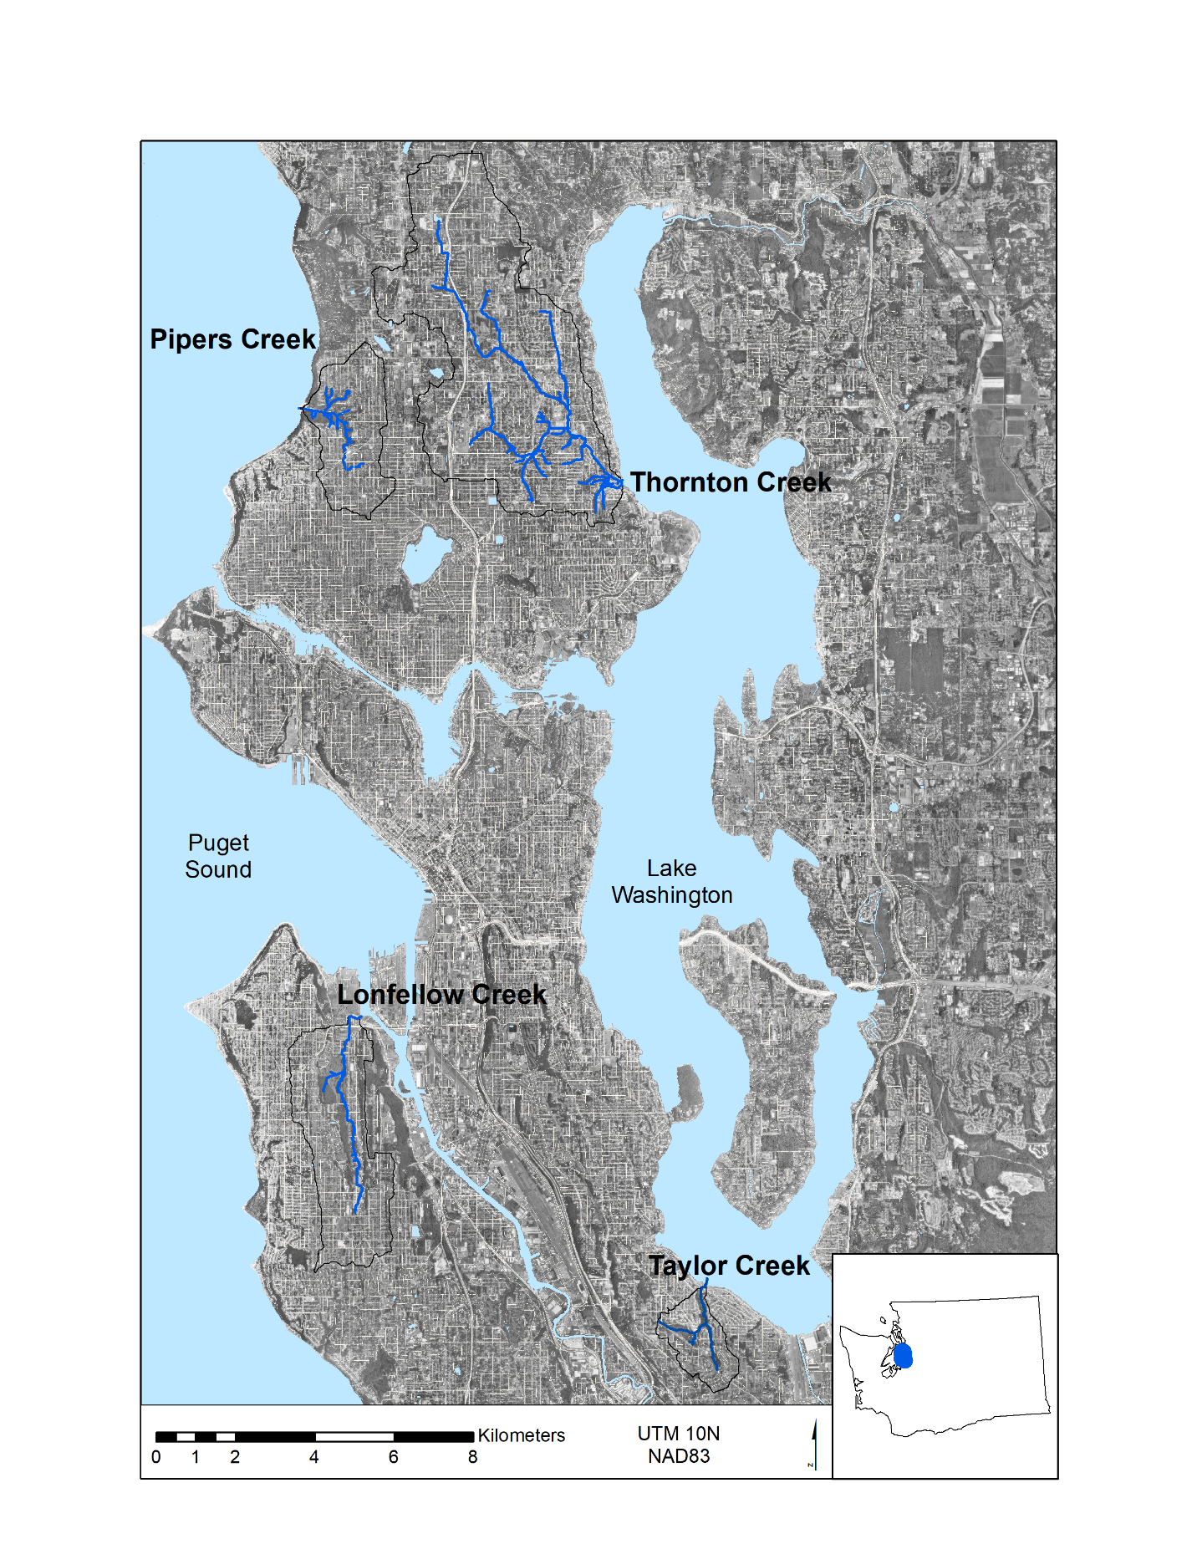

Figure 1. The four watersheds in Seattle, Washington examined in this study. Detailed depictions of the individual watersheds are provided in Figures 3-6.

Layer 2

Layer 3

Layer 4

Green Roof

Impermeable Layer

Boundary

Layer 2

Layer 3

Layer 4

Layer 1

Boundary

Optional Impermeable Layer

Figure 2. A single VELMA voxel depicting lateral and vertical flows. The left panel is a standard VELMA setup, and the right panel is the changed voxel structure to represent green roofs.

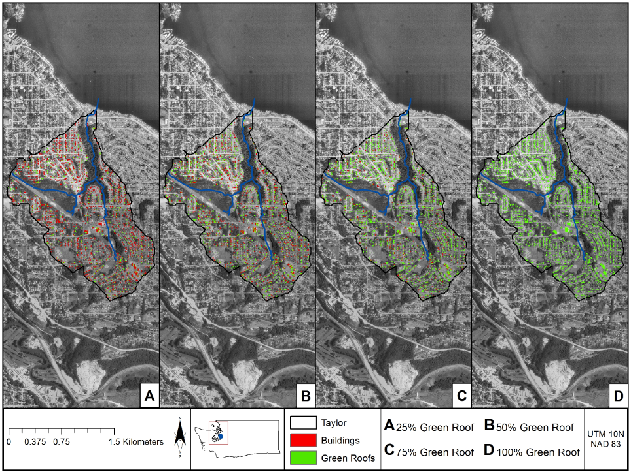

Figure 3. Spatial distribution of green roofs implemented in varying proportions (25%, 50%, 75%, and 100%) of existing buildings within the Taylor Creek watershed.

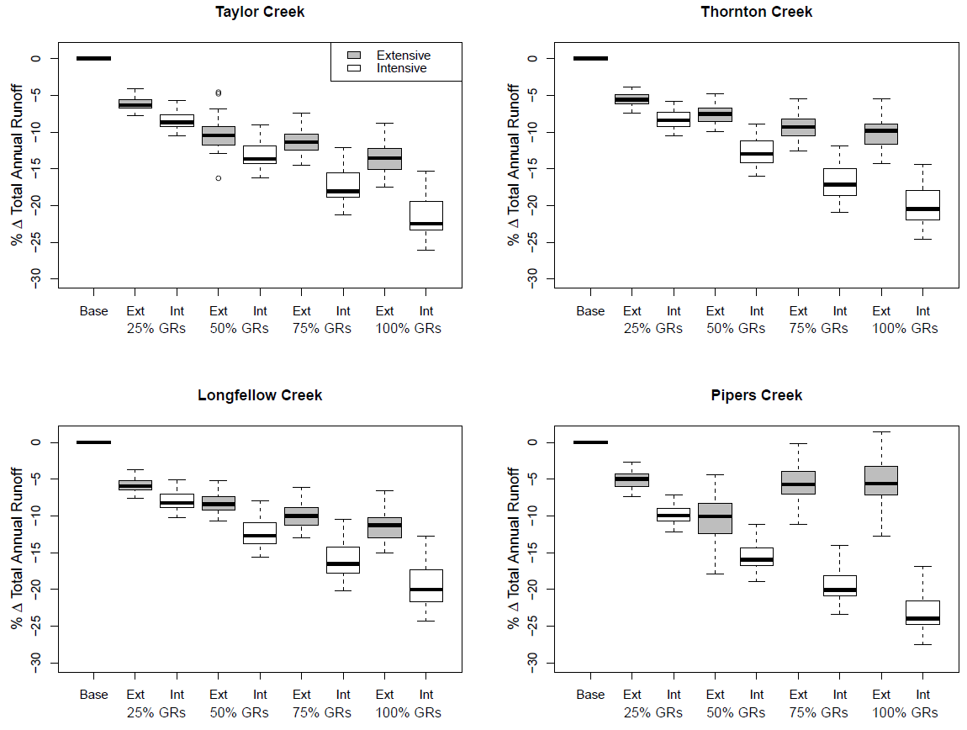

**Figure 7.** Percentage differences between the annual runoff for the baseline simulations and the four scenarios of green roof implementations (25%, 50%, 75%, 100%) for the extensive (gray) and intensive (white) green roof simulations. Simulations were run for 29 years (1987-2015), and the first year was a spin-up year and was not included in the results. The boxplots show the annual statistical variations.

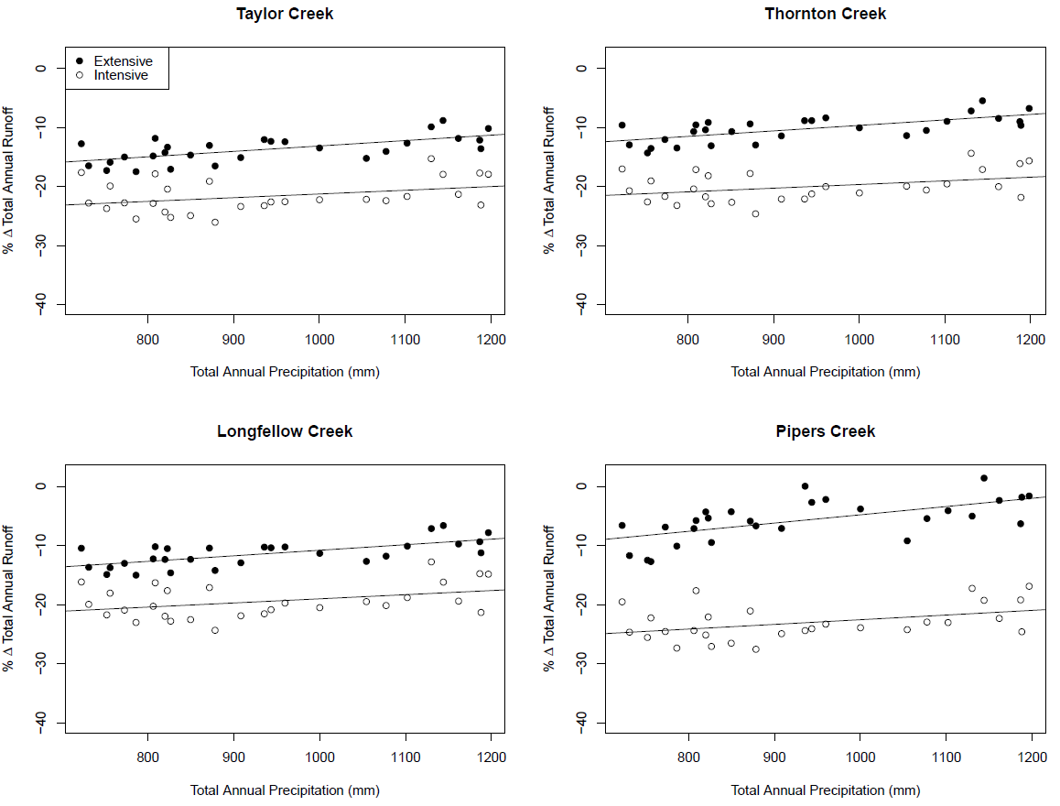

**Figure 8.** Percentage differences between total annual runoff for the 100% green roof scenarios and 0% baseline scenarios plotted versus total annual precipitation for all four watersheds. The extensive and intensive green roof scenarios are denoted as filled and unfilled circles, respectively, and linear regression model fits are included to designate the general data trends. Intensive green roofs more effectively reduce runoff than extensive green roofs due to their deeper soil columns supporting larger vegetation, and both types diminish in efficiency as total precipitation increases, likely due to saturation.

|  |  |  |  |  |
| --- | --- | --- | --- | --- |
| **Table 1.** Within-watershed land use classification percentages. | | | | |
|
|  | **Taylor** | **Thornton** | **Longfellow** | **Pipers** |
| Buildings | 10% | 10% | 10% | 11% |
| Impervious Surfaces (e.g., Roads, Parking Lots, Sidewalks) | 24% | 26% | 31% | 24% |
| Trees | 42% | 42% | 34% | 46% |
| Grass | 24% | 22% | 25% | 19% |
| Watershed Area | 3 km2 | 31 km2 | 11 km2 | 6.5 km2 |

|  |  |  |  |  |  |
| --- | --- | --- | --- | --- | --- |
| **Table 2.** Watershed model input data acquisition and sources. | | | | | |
|
| **Organization** | **Dataset** | **Data type** | **File Format** | **Scale** | **Uncertainty\*** |
| United States Geological Survey (USGS) | National Elevation Dataset | Elevation | Raster | 1/3 arc-second | Z value RMSE = 2.44 m |
| City of Seattle | Urban Streams | Hydrography Dataset | Shapefile | NA | Unknown |
| University of Washington | Land use/land cover | Land Cover/Use | Raster | 1 m | Unknown |
| National Oceanic and Atmospheric Association (NOAA) | Temperature and Precipitation | Daily, Point Location | csv | NA | Unknown |
| ORNL / Daymet | Temperature and Precipitation | Daily, Point Location | csv | NA | Year 2000 Mean Daily Bias: +0.012cm, -0.123 C° |
| United States Department of Agriculture (USDA) | State Soil Geographic data base | Soils | Raster | 10 m | Highly dependent on scale and field methods |

Table 3. An overview of the discharge calibration process for the Taylor Creek watershed.

|  |  |  |  |
| --- | --- | --- | --- |
| **Parameter** | **Uncalibrated Ranges** | **Calibrated Ranges  (NSE > 0.6)** | **Final Calibrated Value** |
| be | 5 - 15 | 5 - 15 | 7 |
| petparam 1 (Conifer) | 0.25 - 1.0 | 0.27 - 0.92 | 0.99 |
| petparam 1 (Grass) | 0.25 - 1.0 | 0.25 - 0.99 | 0.96 |
| ksLat | 0.00001 - 0.001 | 0.00001 - 0.0001 | 0.00009 |
| ksVert | 0.0005 - 0.005 | 0.001 - 0.005 | 0.002 |
| surfaceKs | 500 - 25000 | 522 - 3023 | 800 |

Table 4. Overview of soil characteristics used in the watershed model simulations.

|  |  |  |  |
| --- | --- | --- | --- |
| **Soil Property** | **General**  **(Sandy Loam, 4 layers) McKane et al. (2014)** | **Extensive Green Roofs (1st layer)**  **Rooflite (2020)** | **Intensive Green Roofs (1st layer)**  **Rooflite (2020)** |
| Porosity (v/v) | 0.453 | 0.70 | 0.70 |
| Field Capacity (v/v) | 0.207 | 0.60 | 0.65 |
| Wilt Point (v/v) | 0.095 | 0.12 | 0.12 |
| Hydraulic Conductivity (mm/day) | 770 | 87,000 | 10,000 |
| Bulk Density (g/cm3) | 1.52 | 0.50 | 0.75 |
| Depth (mm) | 500 | 100 | 500 |
| pH | 4.5 | 7 | 7 |

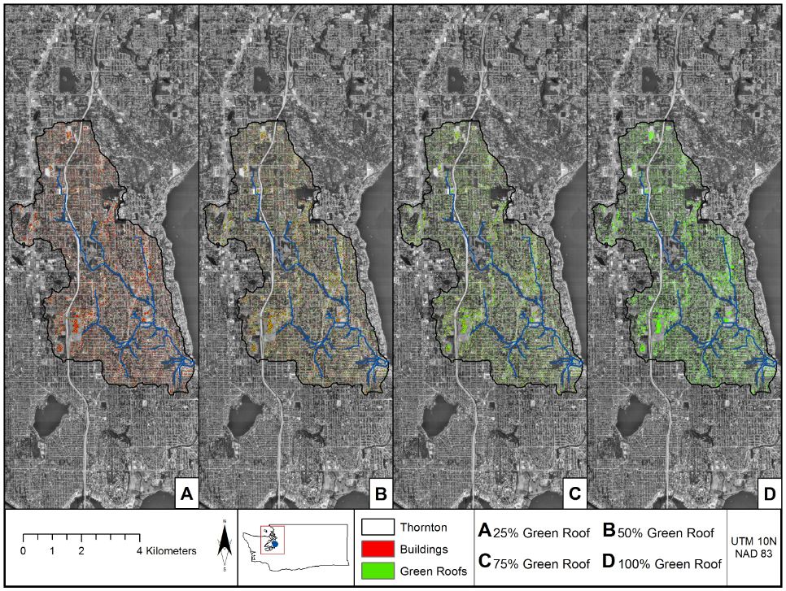

Figure S1. Spatial distribution of green roofs implemented in varying proportions (25%, 50%, 75%, and 100%) of existing buildings within the Thornton Creek watershed.

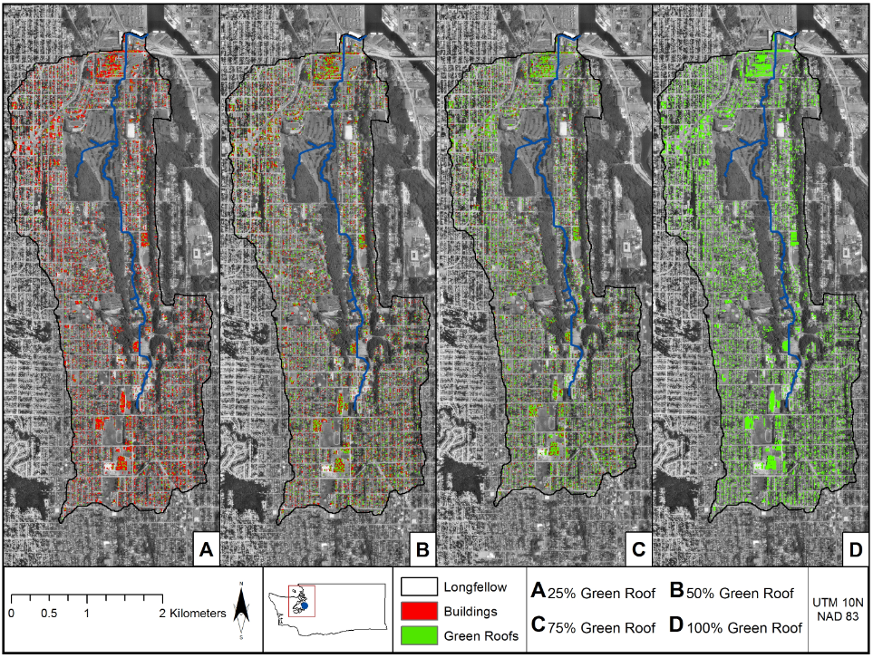

Figure S2. Spatial distribution of green roofs implemented in varying proportions (25%, 50%, 75%, and 100%) of existing buildings within the Longfellow Creek watershed.

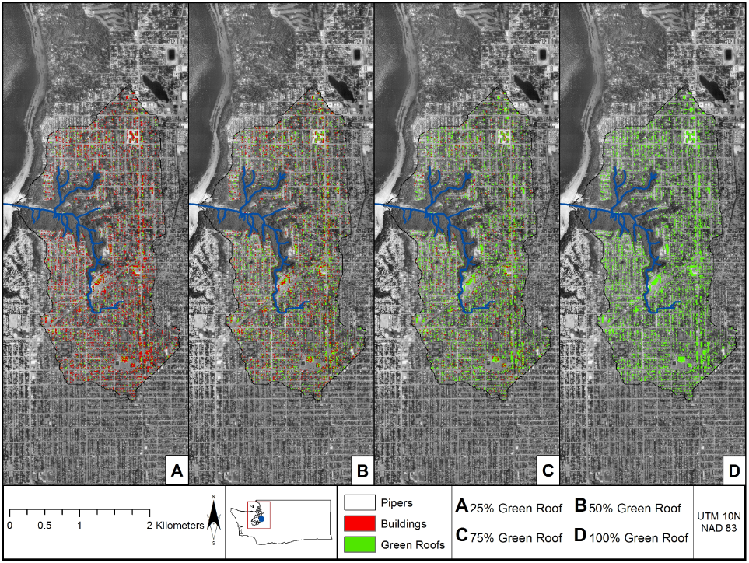

Figure S3. Spatial distribution of green roofs implemented in varying proportions (25%, 50%, 75%, and 100%) of existing buildings within the Pipers Creek watershed.